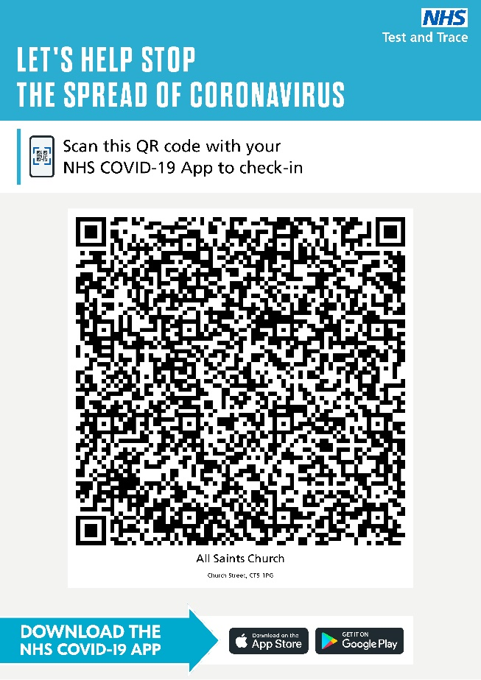

ALL SAINTS WHITSTABLE TEST AND TRACE
FIRSTLY DOWNLOAD THE NHS COVID-19 APP TO YOUR PHONE
ONCE YOU HAVE ARRIVED AT ALL SAINTS OPEN THE APP AND CLICK ON VENUE CHECK IN
THEN SCAN THE ABOVE SQUARE

This will reduce the amount of people queuing up to fill in Test and Trace forms in the church and be more Covid-19 Secure. You do not need to complete a paper Test and Trace form if you do this.

PLEASE ON NO ACCOUNTS HAVE A DEMO SCAN AT HOME AS IF YOU HAVE THE COVID-19 APP INSTALLED ON THE PHONE YOUR APP WILL RECORD YOU AS ALREADY HAVING BEEN INTO THE CHURCH WHICH COULD IN WORST CASE SCENARIO LEAD TO THE APP ASKING YOU TO SELF-ISOLATE FOR 10 DAYS
You can though scan the above box at home if you have returned from church and forgot to check in.

